 | VEDANTA LIMITED –  VALUE ADDED BUSINESS | Format No.: | FRMT/MR/10
 | INTEGRATED MANAGEMENT SYSTEM | Revision Date: | 04.04.2023
 | HAZARD IDENTIFICATION | Revision No.: | 02
 | HAZARD IDENTIFICATION | Page No.: | 1 of 1

Departmental Use Only
Revision No: 01 | Unit: MCD
Revision Date: 15.09.2023 | Dept.: MECH

A Work Activity Information

Sr.No. | Details | Remark
1) | Task being carried out, their duration and Frequency: | Balancing of fan  2-8 hrs.
2) | Location (s) where the work is carried out. | RAM CAR 2 ID FAN  CHARGE CAR 3 ID FAN  BLOWER OF DES AT BATTERY1 CSP  BLOWER OF DES AT BATTERY1 CHP  BLOWER OF DES AT BATTERY2 CSP ST1  BLOWER OF DES AT BATTERY2 CSP ST2  BLOWER OF DES AT BATTERY2 CSP ST3  B-2 DES FAN@36 OVEN AREA  B-2 DES FAN@72 OVEN AREA
3) | Who normally/occasionally carried out the task | Engineer in charge  Work men on the job
4) | Who else may be affected by the work (For example visitors, subcontractors, the public) | Contractor workmen, Production/Electrical Engineers
5) | a)Has the personnel trained for performing the task  b) Any special training required | Yes (Past experience)  No
6) | Is the written system of work mandatory? If yes state the procedure no. | VL/IMS/MCD/WI/MECH/76
7) | Is the work permit required for the task | Yes
8) | Plant and machinery that may be used:  Eg : crusher, conveyor, crane, heavy earthing equipment, Truck etc, | NA
9) | Any electrically operated hand tools are used | Yes
10) | Manufacturer’s or supplier’s instructions for operation and maintenance plant machinery and powered hand tools are available or not: | Yes
11) | Chain block, tools and shackles such as wire rope, hydraulic jack etc are used. | NA
12) | What materials are handled? Size, shape, surface character and weight of materials that may be handled: | Less than 100 gram.
13) | Is the material is required to be moved by hand. If yes Distance and heights of the place where materials have to move by hand. | 2 mt height approximately
14) | Services used Eg: compressed air, oxygen, acetylene,  LPG gas, hydraulic oil, welding electrode for welding | Welding machine, grinding machine
15) | Physical form of substances encountered during the work (For example fume, gas, vapour, liquid, dust/powder, solid): | Solid, fumes, dust,
16) | Content and recommendations of safety data sheets relating to substances used or encountered:  ( this is applicable in case of chemical material) | NA
17) | a) Relevant acts, regulations and standards relating to the work being done, the plant and machinery used and the materials used or encountered:  b) Is the activity is reviewed for compliance to statutory requirement | Factory Act  Yes
18) | What is the data (s) required to be monitored during the activity and the frequency of monitoring. | Monitoring of noise level after every 3 months
19) | Any information available from within and outside the organization on incident, accident and ill health experience associated with the work being done, equipment and substances used: | 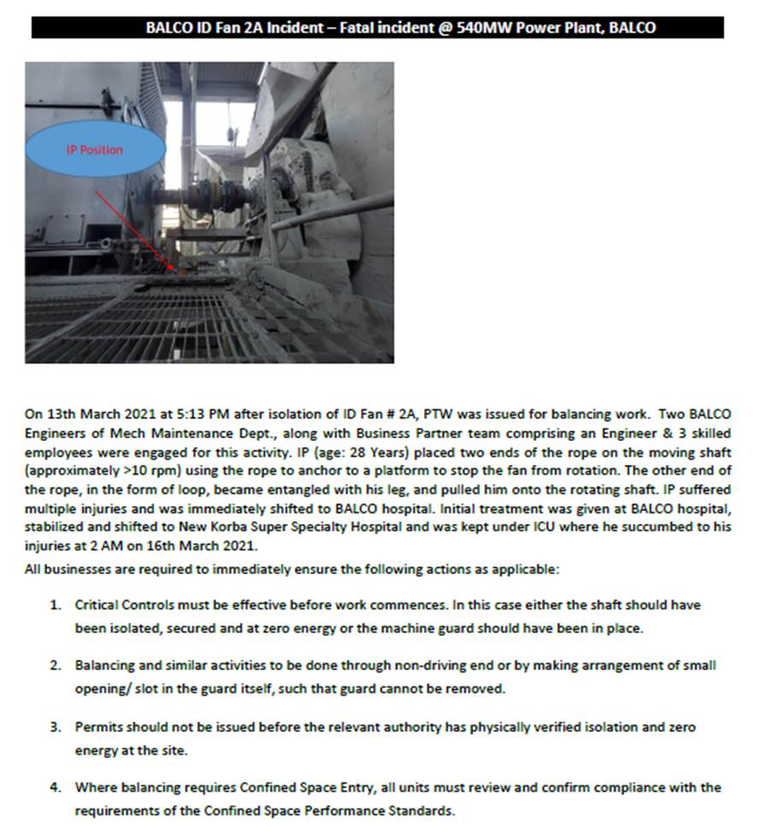

HAZARDS IDENTIFIED

Physical Hazard
- Noise, vibration, pressure, temperature.
- Impact of inspection door / pressurised air due to leakage of air while opening inspection door.
- Slip and fall due to oil spillage.

Mechanical Hazard
- Fall of material Casing, Assembly due to irregular size
- Trapping of person during the fall of material from height
- Fall of material due to mass & stability
- Back Pain.
- Cut from sharp edges of items of fans

Electrical hazard
- Electric shock due to contact with open end cables & superficially laid underground electric cables.
- Electric shock from overhead lines due to contact with overhead lines.

Behavioral Hazards
- Alcoholism.
- Non usage of PPE’s
- Casual approach while working.
Chemical Hazards
- Fire

Prepared By:  Incharge Battery 1 Machine Mechanical Maintenance MCD | Reviewed By:  Head Mechanical Maintenance MCD
Signature: | Signature:
Review Date:15.09.2023 | Review Date:15.09.2023

